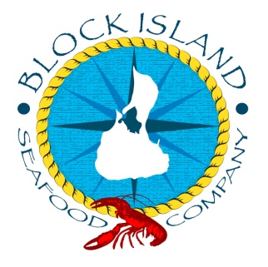
www.blockislandseafood.com

New England Clam Chowder

Ingredients:

6 slices of bacon ½ cup butter
2 cups of diced onion ½ cup of all purpose flour
1 cup of diced celery 1 ½ quarts of light cream
3 cups of diced potatoes 2 ears of corn (cleaned)
1 teaspoon of dried thyme
Pinch of ground pepper
24 large cherrystone clams –shucked, chopped and with the juice

New England clam chowder on a cold day can keep you warm for hours. In New England it’s sometimes called Quahog chowder, “chowdah” and in a restaurant, simply, “white.” In Rhode Island, however, “chowdah” is prepared with a clear broth. I like to mix New England and Manhattan clam chowder and call it Long Island chowder.

The first thing I do is make my roux. Melt the butter and the flour. Stir this mixture till it bubbles. This is your roux and it will work as a thickening agent in the soup. After it is made, put in the refrigerator for later.

In a sturdy pot sauté the bacon till it’s translucent, and then add the onions and celery. When they are soft pour in about 1 ½ cups of the clam juice. The more juice the clammier and thinner the soup will be. Add the potatoes and the cleaned ears of corn and seasoning and let it cook for about ten minutes.

When the potatoes are soft, add the chopped clams, corn kernels, and let it simmer for two minutes. Stir in the roux and let it simmer for 2 more minutes while you scald the cream in a separate pan. When small bubbles appear around the edges of the pan, pour it into your chowder base. Mix it up and enjoy!!!!

