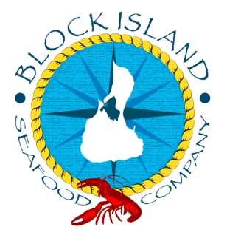
www.blockislandseafood.com

Lobster Mac and Cheese
Ingredients:
6 tablespoons of butter
6 table spoons of flour
1 quart of heated whole milk
½ cup chopped fresh parsley
1 tablespoon chopped fresh tarragon
1 tablespoon chopped fresh thyme
12 oz. gruyere, shredded
8 oz. extra sharp cheddar, shredded
5 oz. Parmigiano-Reggiano
1 pound pasta shells
1.5-2 lbs. of lobster meat
salt and pepper
*******************
1 ½ cups of panko break crumbs
2 tablespoons of butter
2 cloves of chopped garlic
¼ cup of parsley
salt and pepper

Serves 6-8

When you have cooked and de-shelled your lobsters (two or three 1 lb. lobsters would work great), cut the meat up and have it ready for the end of the meal.

Cook the pasta to al dente and also leave that on the side.

Heat the butter in a pan and whisk in the flour. While the roux is cooking, have the milk on a medium heat to warm it up. When the roux is golden color and starting to get thick, slowly add the heated milk and keep stirring top prevent any clumps of roux. Mix in all the milk till it’s free of lumps. Now whisk in the cheese and take the mixture on and off the heat as needed. Now add the herbs, salt, pepper, lobster and shells. This is your lobster mac and cheese!

To make it crunchy you can sprinkle bread crumbs over the mac and cheese and bake it to get a crispy crust over the top. Just set your oven on a high temp or put it under the broiler.
We will get our crispy top from the panko bread crumbs. Melt 2 tablespoons of butter in a strong pan, cast iron if you have, and when it’s melted add the garlic. Get the garlic soft and then add the panko breadcrumbs. Toast the breadcrumbs and parsley till it’s crispy and brown. Spoon this over the mac and cheese.

